

KARACHI BUS ROUTES

**INTRODUCTION**:

Graph analysis of Karachi bus routes that have nodes, edges and vertex through that we make analysis in different ways. Different routes are connected with each other and some of them have special routes.

**DEGREE DISTRIBUTION:**

.

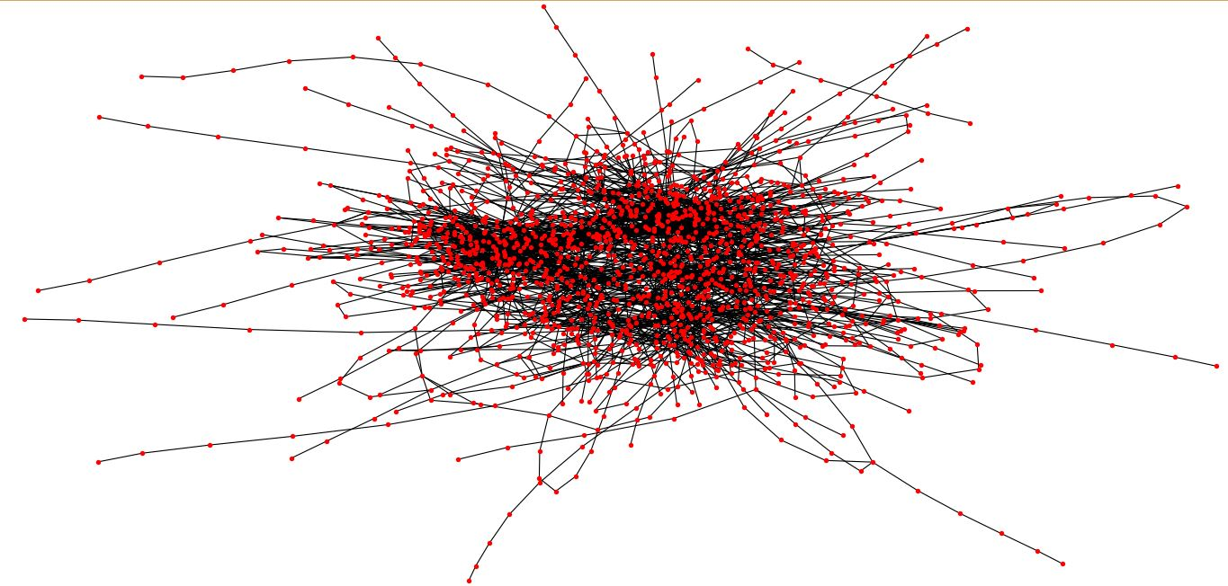

Type: Graph

Number of nodes: 1649

Average degree: 3.5913

Number of edges: 2961

**LEARNING OUTCOMES:**

* We have learned how to make graph using networkx and matplotlib.
* Weanalysis different routes of Karachi where many areas are connected each other.
* Every bus has their own territory they do not interfere with other bus routes.

**GROUP MEMBERS:**

18b-030-CS (B)

18b-028-CS (B)

18b-027-CS (B)

18b-045-CS (B)

rr